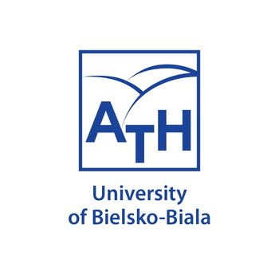
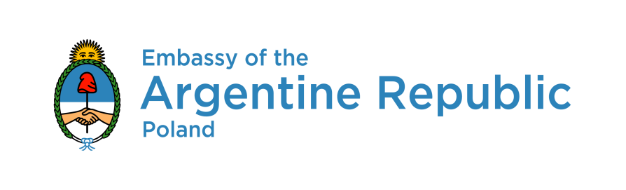
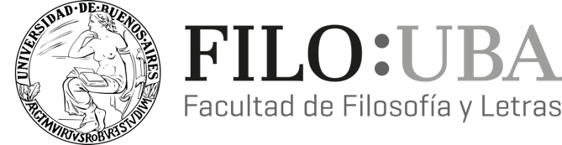

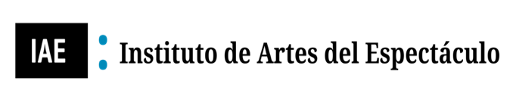

CIRCULAR

2nd International Academic Conference
Theatricality – Antitheatricality:
Transdisciplinary and Scenological Studies on Contemporary Theater

MAIN TOPIC (non-exclusive)
The body of the spectator

16 - 18 December 2020

ORGANIZERS:
Institute of Modern Languages / University of Bielsko-Biala (POLAND)
Institute of the Arts of the Spectacle / University of Buenos Aires (ARGENTINA)

THEME PROPOSAL
The topic of the conference Theatricality – Antitheatricality: Transdisciplinary and Scenological Studies on Contemporary Theater leads us this year to the problem: The body of the spectator (Jean-Marie Pradier). The topic of the conference we want to explore serves a purpose of investigating different realities and thoughts of the spectator from various scenological and theatrical points of view. The orientation appears to be generally set from the perspective of the stage. But what has happened to the other parts of the spectacle – the zone which seems to be in the shadow subsumed in absolute silence? We refer to the body of the spectator or the subject that promptly fades into antipresence or even more – in the existence of antitheatricality. What relations and differences are established in the dynamics among the spectators living in convivio, in technovivio or between the two (Dubatti)? If this spectator, the body, is absent or, at least, cannot be perceptible, does the cultural model of representation make any sense? The theater is in essence the representation in conviviality, at least in the history of our cultural tradition. But in this new culture that is coming, in this new era, will the framework of the representation and its observer be the game of realities that are envisaged for the theater? And vice versa, if the spectator wants to regain the ground lost in their field, because eventually they would want to enter a spectral zone where anonymity prevents them from behaving as that stage presence, what must they submit to in order to achieve this goal. Should they regain their physical status? Who is the spectator? Is the body? On maybe the one who is watching? Or merely an entity of meaning forged in the experience of modernity? Obviously, there are much more questions pertinent in such a context of inquiry, but here we will take only one more as an effect to leave the rest to the imagination, that is: Are we actually facing the end of the social and therefore the one who is watching is an entity that is no longer necessary? Those are the major problems we hope to consider during these three days of presentations. Since it is not possible to attend (as the expression says) in "body and soul" we want to invite you to share this universe of theoretical irregularities and increasingly diffuse fields of research to analyze the ancestral figure of the one who endorses the representation: the spectator, who – together with their material quality carried in the body – challenges and contests contemporary society. Does the figure become more and more ephemeral and leave its place of presence? Or does it try to regain its status, the one that has been granted by modernity, that of being a body loaded with critical and epistemic knowledge.

Important note: Other proposals that are cross-cutting to the central theme of the conference – set within the framework of Scenological Studies, theatricality, and the original themes of our theatricality-antitheatricality conference – will be accepted.

Conference working languages: Spanish, English

Conference activities:

Seminars

Discussion panels

Open debates

Presentation of authors’ monographs and journals

Plenary speakers (45 min)
Prof. Cécile Chantraine Braillon (La Rochelle University, France)
Prof. Jorge Dubatti (University of Buenos Aires, Argentine)
Prof. dr hab. Krystyna Duniec (Instytut Sztuki Polskiej Akademii Nauk – PAN, Poland)
Prof. ATH dr hab Carlos Dimeo (University of Bielsko-Biala, Poland)

Special lectures (30 min)
Prof. Percy Encinas (University of San Marcos, Peru)
Prof. Carlos Dimeo (University of Bielsko-Biala, Poland)
Prof. Lucas Magarit (Unversity of Buenos Aires, Argentina)
Prof. Mauricio Tossi (CONICET, Argentina)

Special events
Meeting with the members of the REDIEE (Red Internacional de Escuelas de Espectadores) from Argentina, Bolivia, Brazil, Colombia, Costa Rica, Spain, France, United States, Mexico, Peru, Poland, Dominican Republic, Uruguay, Venezuela.

Open debate
Interview with a playwright Héctor Levy-Daniel / on the basis of the monograph Las mujeres de los nazis and its Polish translation Kobiety Nazistów (trans. Carlos Dimeo and Michał Kopczyk)

Presentation of the book
Artistas-Investigadores/as y producción de conocimiento desde lo escénico. Hacia una Filosofía de la Praxis Teatral, published by La Escuela Nacional Superior de Arte Dramático “Guillermo Ugarte Chamorro” of Lima, Peru.

Payment details:
The participation in the conference is free of charge.
The publication of accepted papers in Eventos Académicos managed by the Institute of the Arts of Spectacle of the UBA will also be free.
A payment will be requested from the authors if their works are selected to be included in a monograph to be published by a prestigious publisher (more details shall be provided in the next circular).

Submissions:
Proposals for papers with abstracts (ca. 250-300 words) and a brief bio with institutional affiliation (if any) and an email address should be submitted electronically in a Word doc. format by 7 December 2020 to the following e-mail address:
iconf.theatre.antitheatre@gmail.com
Notifications of acceptance will be sent out by 9 December 2020.
Length of presentation: 15 minutes
Each session will be followed by a 10-minute discussion with the audience.

The conference will be organized online as a Zoom meeting and retransmitted via the YouTube channel of the Institute of the Arts of Spectacle of the UBA, the platform of Facebook Live of the Embassy of Argentina in Poland as well as the account of Facebook Live of the University of Bielsko-Biala. The papers will be published in a digital form by the Institute of Arts of the Spectacle of the UBA (iae.institutos.filo.uba.ar). Selected papers will be published with a prestigious academic press.

Scientific Committee:
Prof. Patrice Pavis (University of Paris 8)
Prof. Anna Węgrzyniak (University of Bielsko-Biala)
Prof. Jorge Dubatti (University of Buenos Aires)
Prof. Marek Bernacki (University of Bielsko-Biala)
Prof. Maria Machnik-Korusiewicz (University of Bielsko-Biala)
Prof. Carlos Dimeo Álvarez (University of Bielsko-Biala)
Prof. Michał Kopczyk (University of Bielsko-Biala)
Prof. Dorota Fox (University of Silesia)
Prof. Lucas Margarit (University of Buenos Aires)
Dr. Aneta Głowacka (University of Silesia)
Organizing Committee:
Prof. Carlos Dimeo Álvarez / Prof. Jorge Dubatti (Coordinators)
Dr. Agnieszka Palion-Musioł
Dr. Tomasz Jerzy Brenet
Alekasandra Hasior, MA
Artur Biela, MSc

